Google Dart News Website Project
Weiqing MAO, Perth, Western Australia, 24/04/2013
Introduction:
Both the server and client of this website are written in Google Dart programming language, along with Rikulo(Stream), HTML, CSS, DOM and Ajax Techniques. The website allows users to upload news in term of text, photos to the server via Ajax and it loads the news information on top of Google Map. It also utilizes Google Geolocation, Google Map JavaScript.
System Environment:
Microsoft Windows Version 6.1(Build 7601: Service Pack 1) Windows 7 Home Premium x64
Rikulo Steam v0.7.0
Dart Editor 0.4.3_r20602
Dart SDK 0.4.3.5_r20602
URL: 10.1.1.3:5050
Overview:
It all starts with an idea, a scratch, and an attitude to make it.
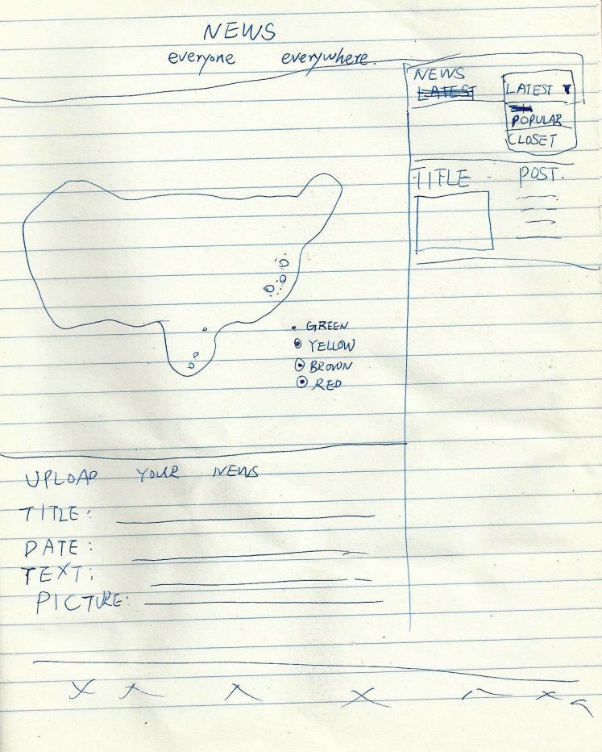
After four weeks of time of implementing of ideas that emerged from bathroom, kitchen, and as such, from time to time, here it is.
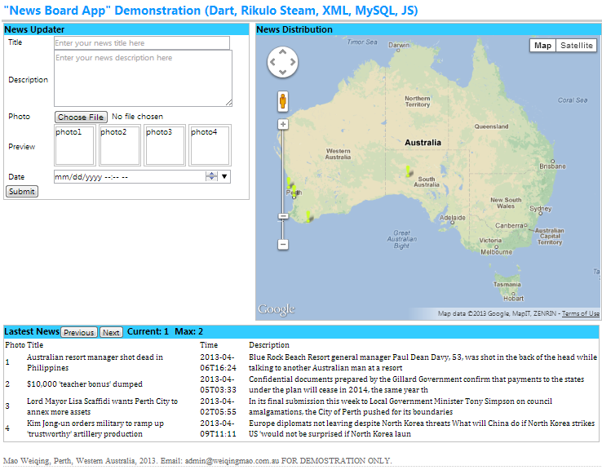
Drag and Drop function: Swift photos easily by dragging and dropping preview photos.
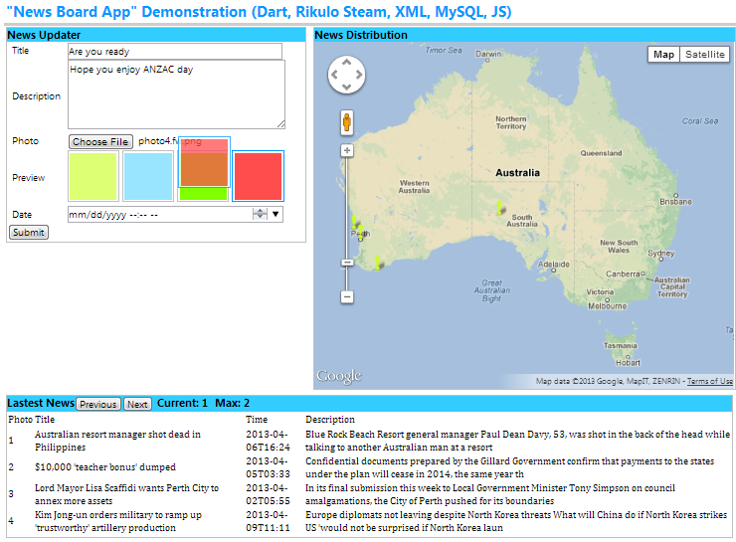
Title, Description, Photos, and Date are uploaded by Ajax, and loaded in the Info Window of Google Map, the markers, CSS tabs, and CSS carousel of which are customerised.
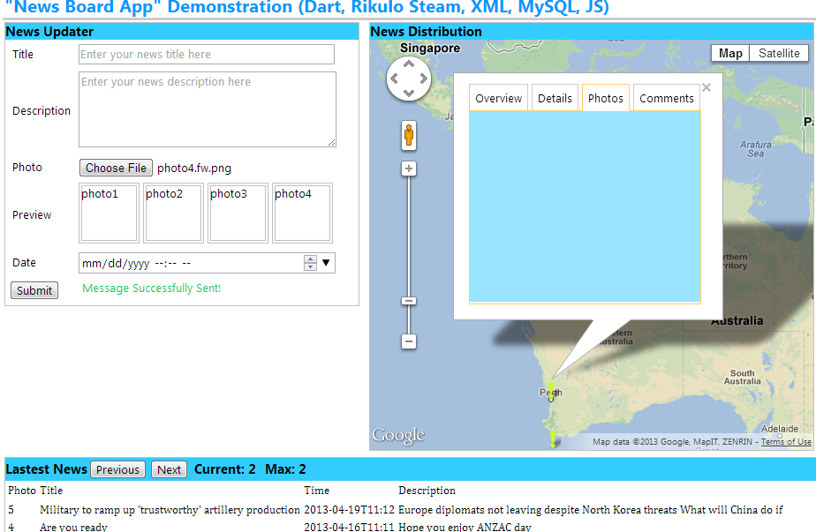
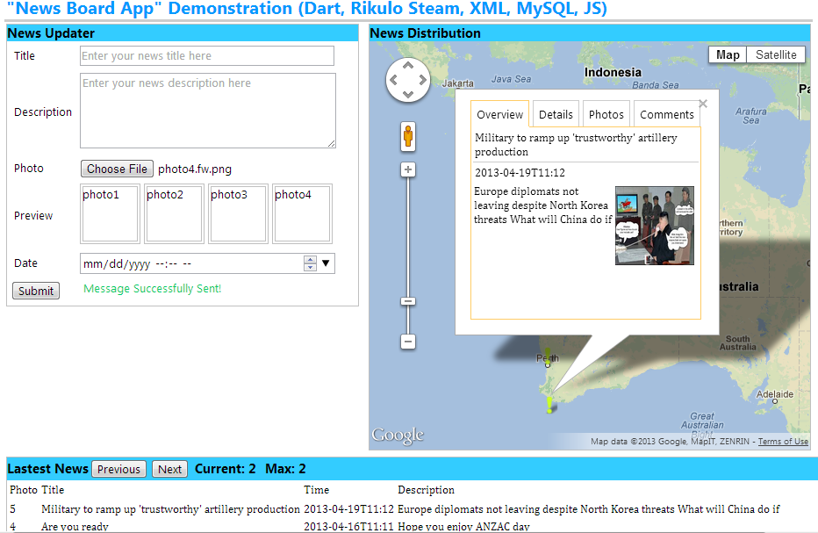
By using Ajax, the websites do not have to refresh, every time the user makes a request.
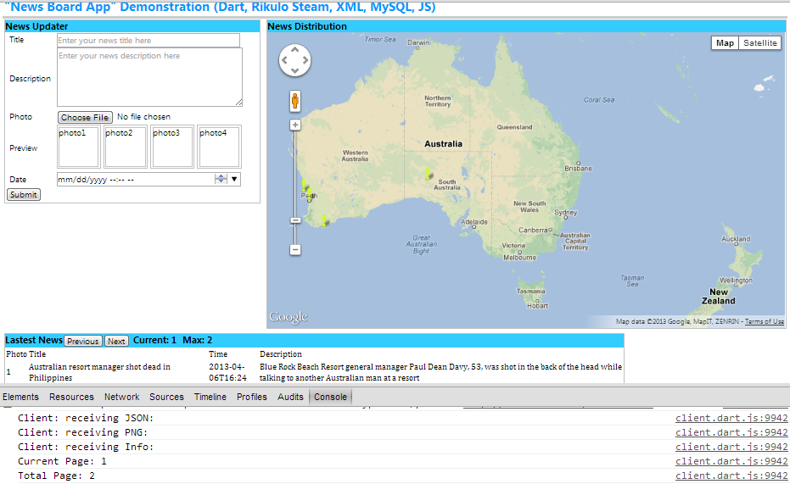
Statics:
Days: 40 days
Labor: 1 person
Code:
Github:
https://github.com/allen-ecu/news_app_v2/

